

CHEMISTRY 3A/B

MAJOR TEST 4

CHAPTERS 9, 10

**TIME ALLOWED 60 minutes**

This test is made up of two sections

Section 1 contains 19 multiple choice questions worth 19 marks

Section 2 contains 6 questions worth 38 marks

Section 1 :

The following information refers to items 1 and 2:

The button cells used in hearing aids, watches and cameras is often the alkaline

silver oxide/zinc cells. When these cells are in operation the cell potential is 1.5 V and the overall cell reaction occurring is:



1. In the reaction above the change in oxidation number of the silver is:

A +1 to 0

B -1 to 0

C +2 to +1

D +2 to 0

E 0 to +1

2. In this button cell, zinc forms

A the cathode and is reduced

B the positive electrode and is oxidized

C the negative electrode and is reduced

D the negative electrode and is oxidized

3. The oxidation number of chromium in the compound, potassium chromate, K2CrO4 is:

A 7

B 6

C 4

D -2

4. Which one of the following species (atom or ion) would you expect to be the strongest oxidant ?

A Br -

B Ag+

C Pb2+

D Mg

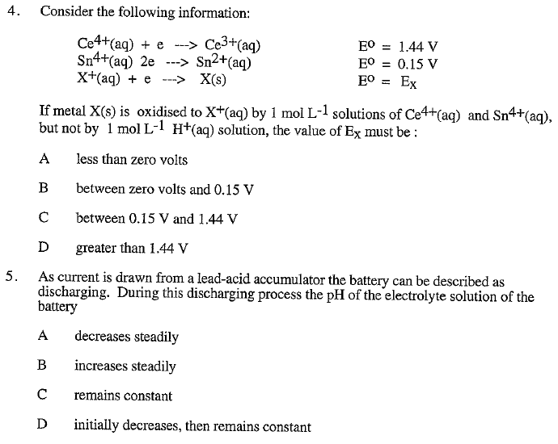

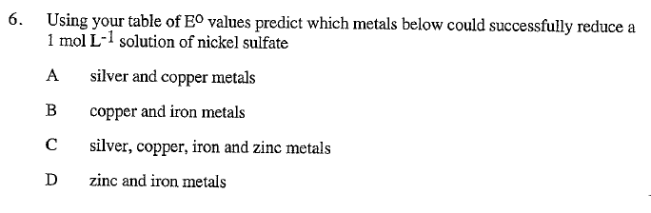

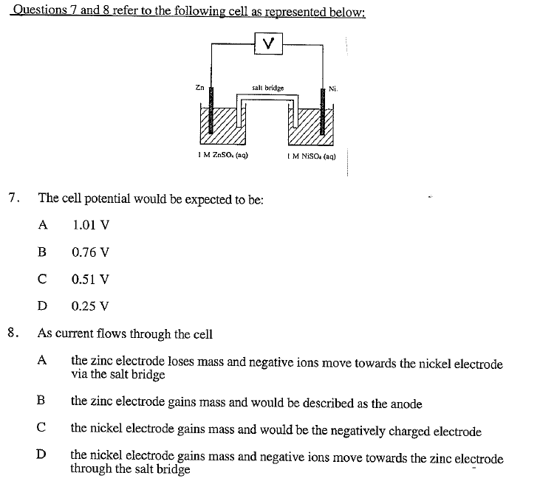

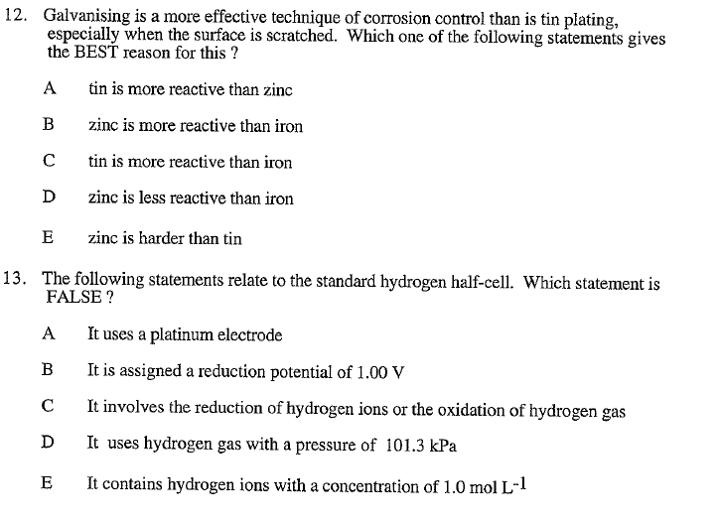

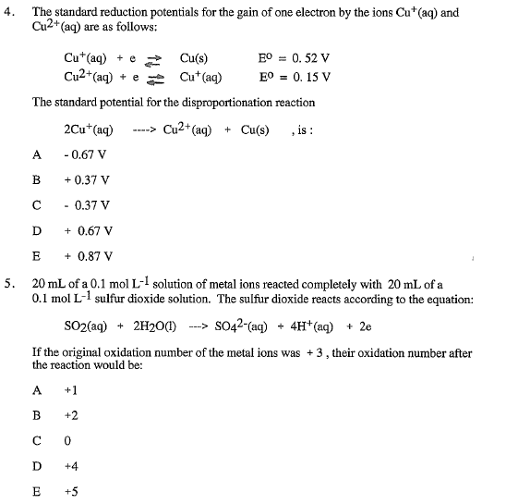

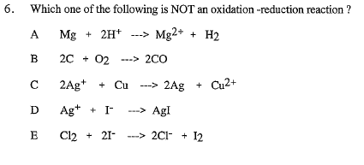

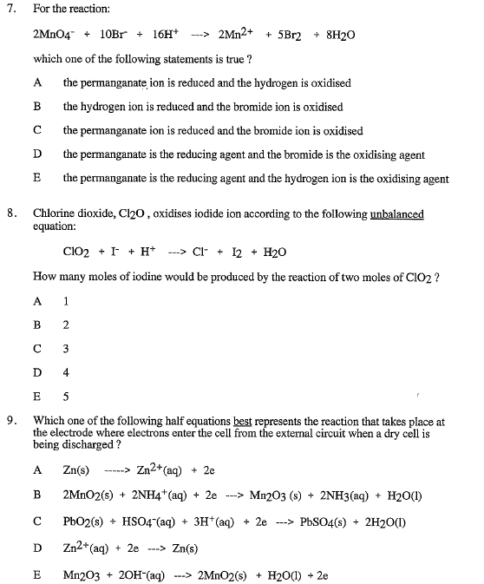

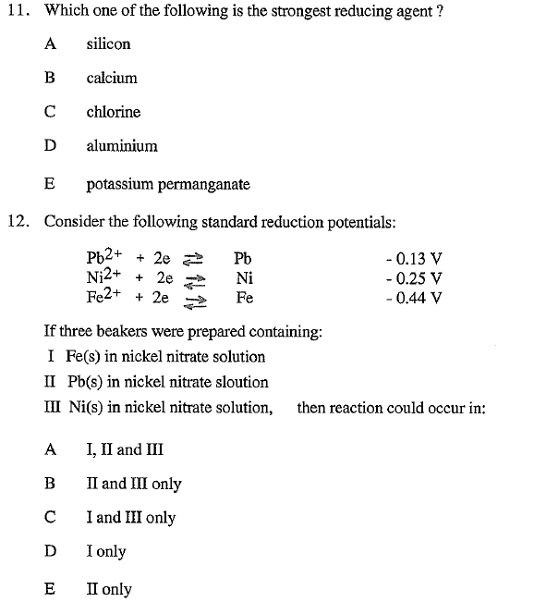

SECTION 2: ANSWER THESE QUESTIONS IN THE SPACES PROVIDED.

1. Balance the following equation by first writing the relevant half-equations:  
  
 

|  |
| --- |
|  |

(4 marks)

2. Metals X, Y and Z and ions of these metals are known to undergo the following reactions:  
  
 Z(s) + X2+(aq) → Z2+(aq) + X(s)

X(s) + Y2+(aq) → X2+(aq) + Y(s)

Z(s) + Y2+(aq) → Z2+(aq) + Y(s)

List the metals in order of increasing reductant strength.

|  |
| --- |
|  |

(3 marks)

3. An electrochemical cell is constructed using two half cells. One half consists of an inert platinum electrode and a solution of Fe2+ and Fe3+. The other half cell consists of a lead electrode and a solution of Pb2+.

Current will flow from one electrode to the other electrode when the cell is completed using a voltmeter and a salt bridge.

(a) Write relevant half- equations and a balanced net ionic equation for the overall cell reaction.

|  |
| --- |
|  |

(b) Calculate the standard cell potential (Eo ).

|  |
| --- |
|  |

(c) Identify the anode, cathode, metals and ions by labelling the following diagram.

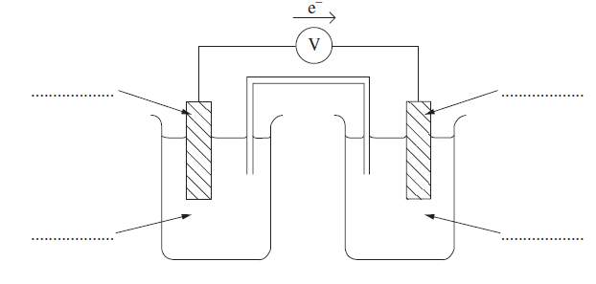

(d) Identify an appropriate electrolyte to use in the salt bridge. Write it on the diagram above.

(3 + 1 + 3 + 1 marks)

4. The button cell present in the watch you are wearing is most likely to be made from silver oxide and zinc. The cell reaction occurring is best expressed as:



The cell potential of one of these cells is 1.50 V

1. Write the half-equations for the reactions occurring at the anode and cathode. Label each one.

|  |
| --- |
|  |

1. Name the oxidant and reductant in the cell

|  |
| --- |
|  |

1. From the information provided in the question and your Eo table determine the standard reduction potential for the half-cell containing Ag2O(s).

|  |
| --- |
|  |

(3 + 1 + 2 marks)

5. A lead-acid accumulator or car battery produces a steady voltage of 12V when it is being discharged. The battery is made up of six cells connected in series and each contains a lead electrode and a lead (IV) oxide electrode in a 4 mol L-1 sulfuric acid solution.

1. Using your data sheet, write the two half-cell reactions occurring and label them the reduction half-equation and the oxidation half-equation.

|  |
| --- |
|  |

1. Which electrode is the cathode and which is the anode?

|  |
| --- |
|  |

1. The actual voltage produced by each of the six cells is about 2.2 V which is different to the value predicted using the Eo table. Why is this?

|  |
| --- |
|  |

1. Write an equation for the overall reaction which occurs when the battery is being recharged.

|  |
| --- |
|  |

1. Sulfuric acid is more dense than water. Explain why measuring the density of the sulphuric acid in the battery can give an indication as to how ‘charged’ the battery is.

|  |
| --- |
|  |

(2 + 1 + 1 + 2 + 2 marks)

6. A vitamin C enriched fruit-flavoured cordial, that can be diluted with water to make a drink, contains citric acid (C6H8O7), vitamin C (C6H8O6) , cane sugar, artificial blackberry flavouring and a preservative. The chemical name for vitamin C is ascorbic acid.

The cordial was analysed to determine the amount of citric acid and vitamin C present.

Vitamin C can be determined, by oxidation, to dehydroascorbic acid, with a solution containing I3-, according to the equation:



1. A 30.0 mL sample of the undiluted cordial was found to react completely with

19.87 mL of 0.0150 mol L-1 I3- solution. Calculate the concentration, in mgL-1, of vitamin C in the undiluted cordial.

The total amount of acid (ascorbic and citric) can be measured by titration with a solution of sodium hydroxide. From this calculation and your answer to (a) above, the citric acid content can be determined.  
  
(b) A second 30.0 mL sample of the undiluted cordial was titrated with 0.0922 molL-1 NaOH. A volume of 9.18 mL was required for complete neutralization. Assuming both citric acid and ascorbic acid are monoprotic acids (see note at end) and that they are the only acids present, calculate the concentration, in mg L-1, of citric acid in the undiluted cordial.

(c)The cordial is intended to be diluted with water for drinking purposes by mixing one   
 part cordial with four parts water. What volume of this final (diluted drink) should be   
 consumed each day if the drinker is to obtain a daily dose of 250 mg of vitamin C.

|  |
| --- |
|  |
|  |
|  |
|  |
|  |
|  |
|  |
|  |
|  |
|  |
|  |
|  |
|  |
|  |
|  |
|  |
|  |
|  |
|  |
|  |
|  |
|  |
|  |
|  |
|  |
|  |
|  |
|  |
|  |
|  |
|  |
|  |
|  |

(3 + 4 + 2 marks)

Note: although ascorbic acid is diprotic is doesn’t actually donate the second proton unless the conditions are very alkaline – this means for determining acidity in juices we can assume it behaves as a monoprotic acid